My computer IP address is 192.168.1.46

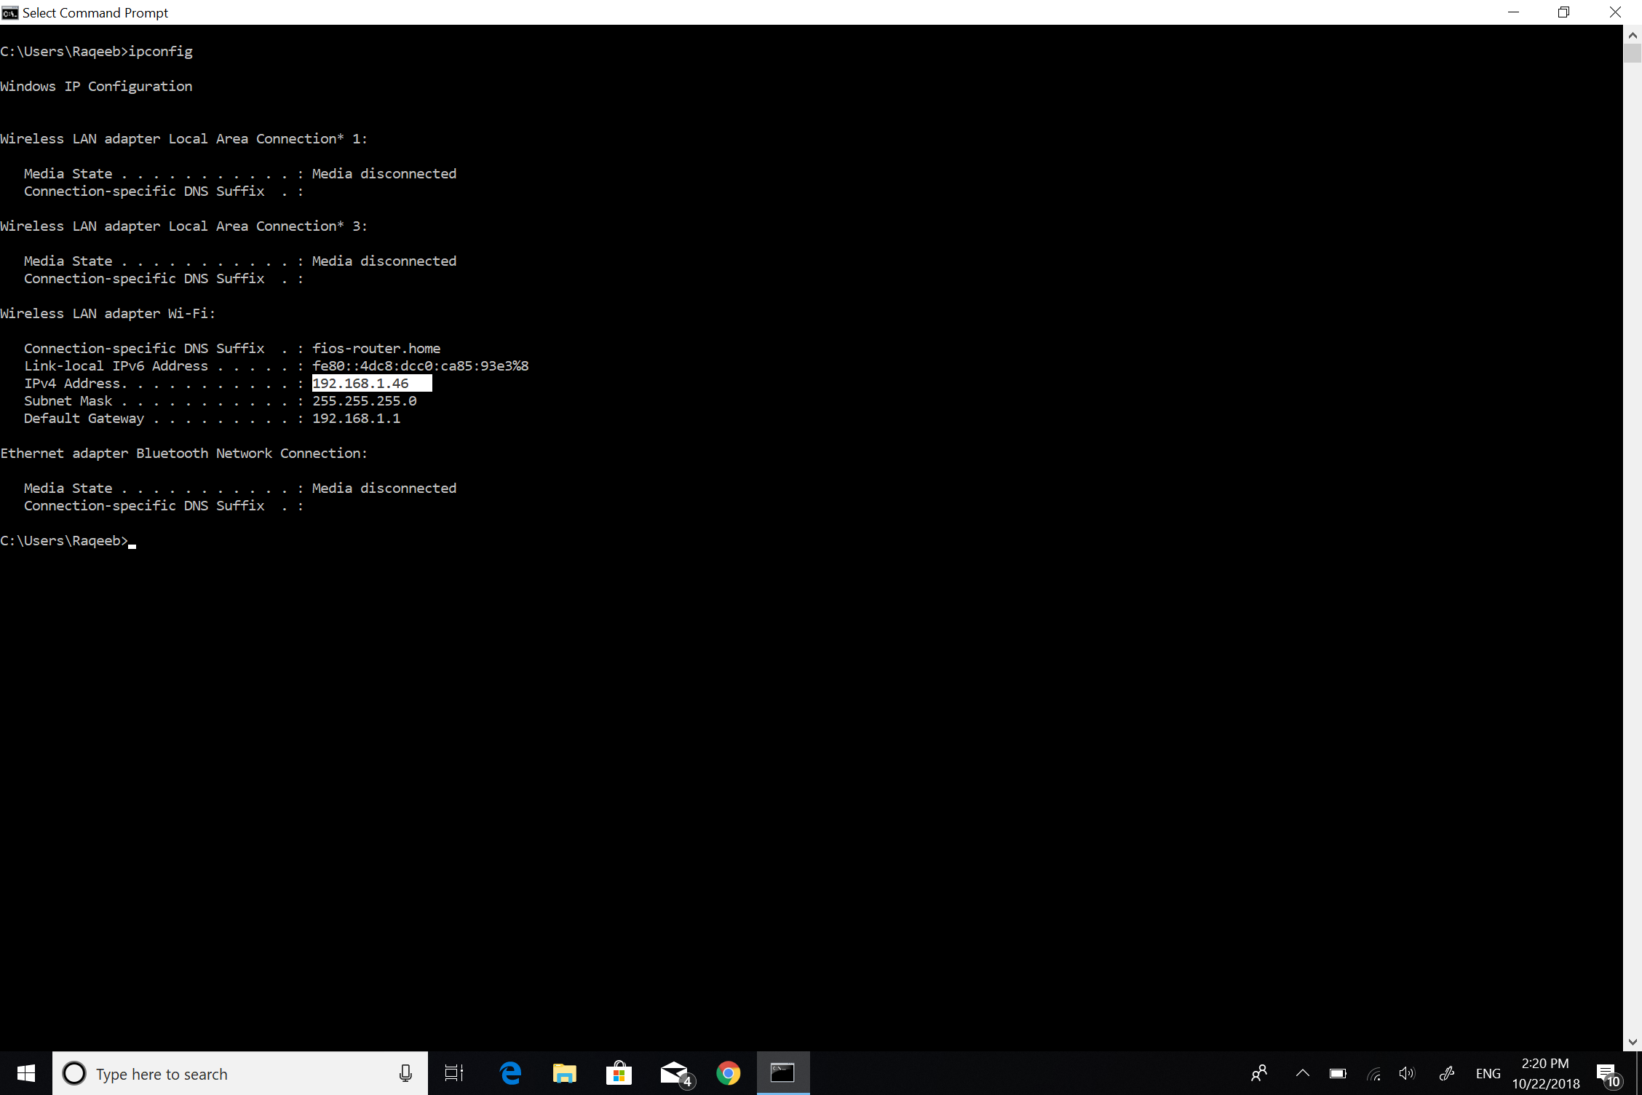

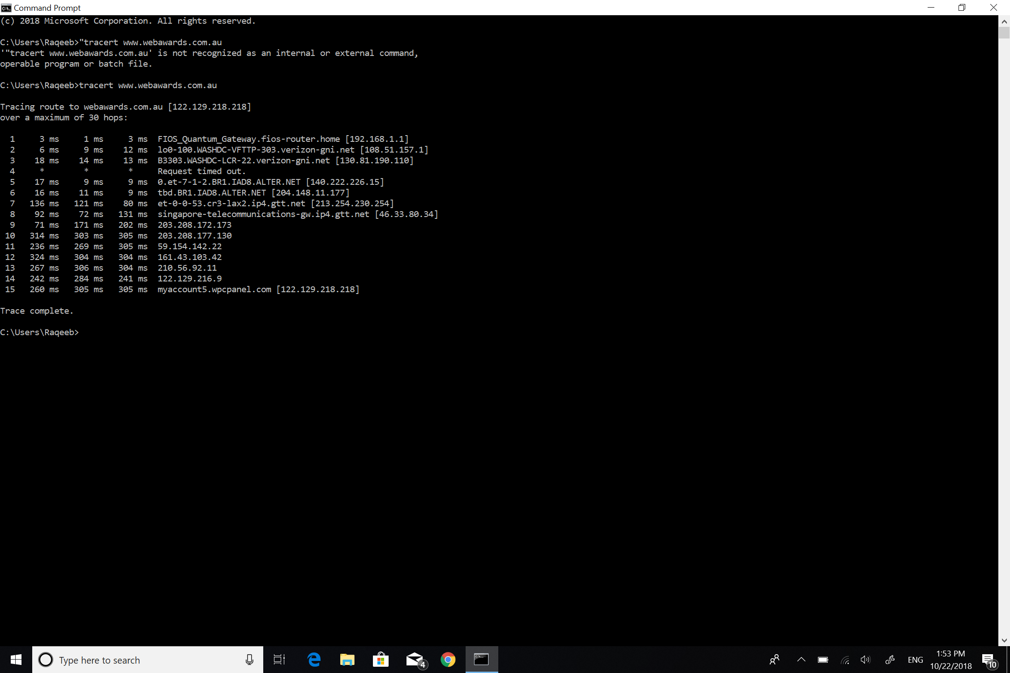2: With reference to private/public IP addresses, the first IP address is a public IP address (192.168.1.1).

3: With reference to private/public IP addresses, the second IP address showing in my traceroute is a public IP address.

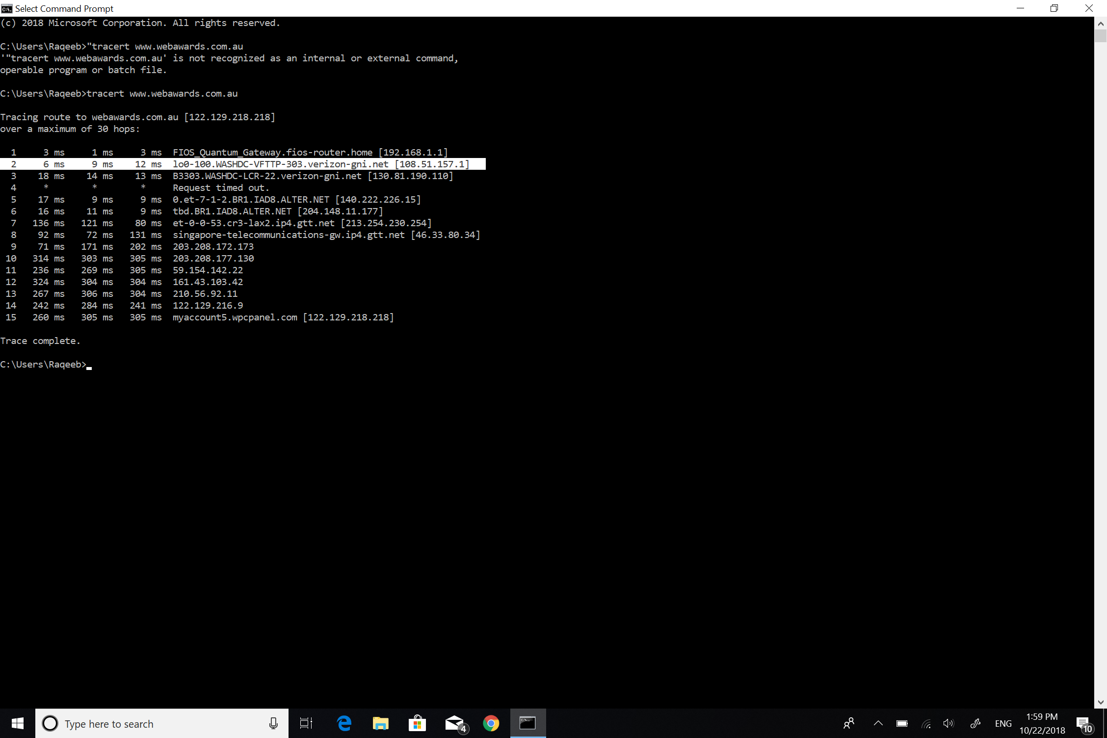

4:

|  |  |  |  |
| --- | --- | --- | --- |
| Hop Count | IP address | Organization  (IP Owner) | Location (US state) country |
| 1 | 130.81.190.110 | MCI Communications Services, Inc | Ashburn, VA, USA |
| 2 | 140.222.226.15 | ANS CO+RE Systems, Inc | 100 Manhattanville Road Purchase, NY, USA |
| 3 | 204.148.11.177 | ANS Communications, Inc | Ashburn  VA, United States |

5: The IP address I used to trace went trough my FiOS router to a router in Ashburn and then bounced from there to another router located in Ashburn and from there it directly went to Singapore where the main host is located.